General

On Form surfaces, there are two button sizes – small and large.

Small buttons are always 24x24 pixels in size, and are used to start a tool or function.
Large buttons are always 75x24 pixels, and are used to close the Form.

Examples:
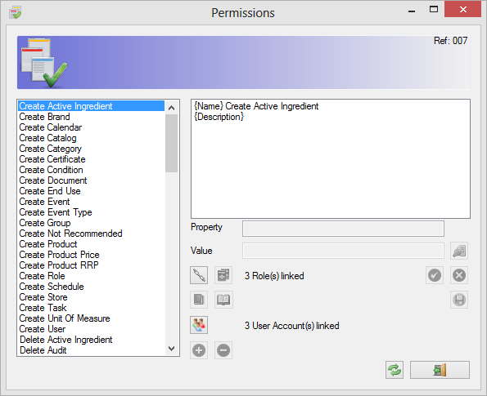

Will close Form
Will not close Form

Graphics
Images and Icons used throughout the application show a consistent view of information, even though the images may be different sizes.

For example, the Edit Menu has the following images:
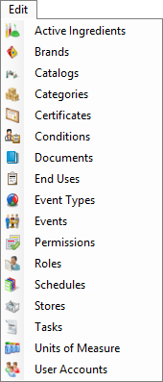

The Toolbar has the following images:

Even though the Menu shows images that are 16x16 pixels in size, and the Toolbar uses images that are 32x32 pixels, the images used are the same.

This consistency is shown throughout the application. For example, the following partial screenshot is from the Events Form:

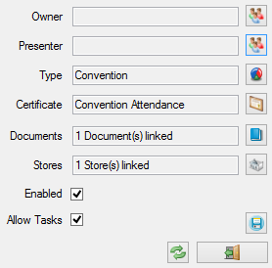

References
Each form has a reference shown in the upper-right corner.
Because each Form has multiple uses, and also may look similar to another, the reference is used to ensure all communications about the application correctly describe the Form.

For example, Form reference 007 is used to allow the user to select from a list. The list may be Categories, Ingredients, Event Types, or one of the other lists, as shown below:

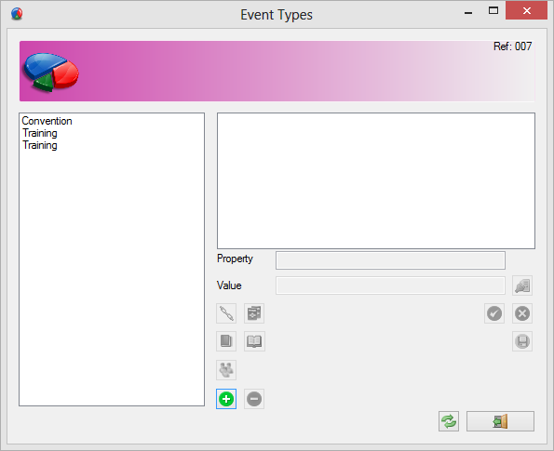
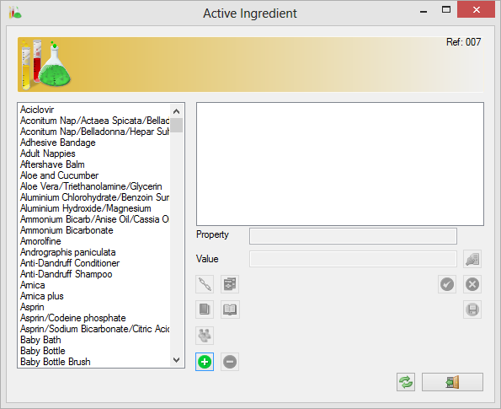
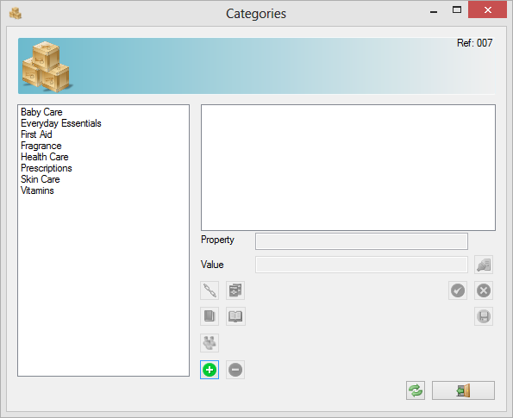

Even though a different list is shown in each Form, the reference (007) tells the user that the same Form is in use.

Colours
As already shown, colours are used throughout.

The colour of each Form’s top panel describes the function, or use of that Form.
For example, the following forms have a connection to User Accounts:

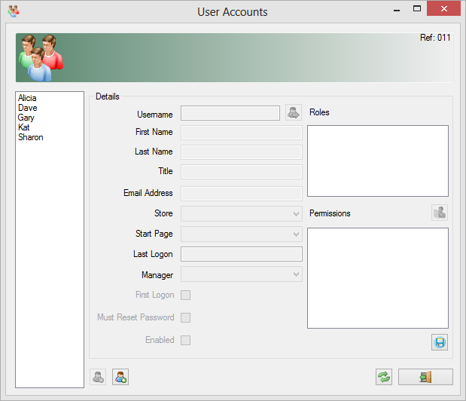

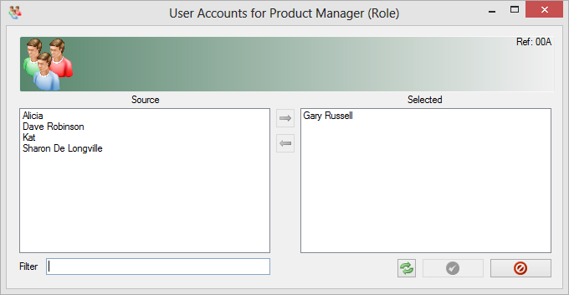

The first Form shows all User Accounts, whereas the second Form shows a list of user Accounts for membership of the Product Manager Role.

Colours used will be consistent through all sessions of the Application.

Multi Document Interface

By default, a Multi Document Interface (MDI) is presented to the User. This allows the User to see a different “Start Page” depending upon their focus.

For example, Users that are primarily interested in Product Administration will probably prefer to see the Product Search page, whereas Users that are more concerned with Task management will refer to see the Tasks page.

Start Page

The Start page for each user is defined in three ways.
- The User Account Form can be used to define the Start page for a number of Users quickly and easily.
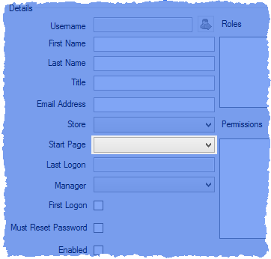
- The Options Form can also configure this for the currently logged-on User Account.
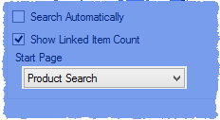
- The User Account Details Form shows User settings for the currently logged-on User Account.
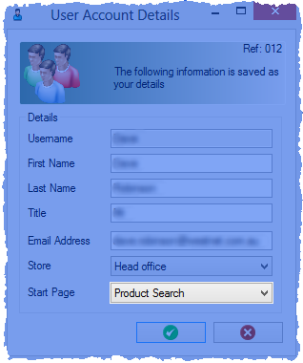

Linking
Many different items can be linked together. For example, Products are linked to a Category, a Brand, an Active Ingredient, and others.

When viewing this linking, the way the information is presented depends upon the User’s point-of-view.
To continue the above example, even though each Product only has one Brand, that same Brand will probably be linked to multiple Products. This type of relationship applies to multiple lists.

The following images shows the main linking allowed:

